6. Probability (Level 1, revisited at Levels 3, 5, 6)
Covers: Sample spaces · conditional probability · Bayes' theorem · independence · random variables · expectation/variance/covariance/correlation · conditional expectation · law of total expectation/variance · CLT · law of large numbers · Bernoulli/Binomial/Geometric/Poisson/Uniform/Normal/Lognormal/Exponential/Student-t/Chi-square/F distributions · joint/marginal/conditional distributions · copulas (awareness) · heavy tails · extreme values (awareness)
▸ INTUITION FIRST
Probability formalises a simple habit of mind: some outcomes are more likely than others, and there is exact arithmetic for combining those likelihoods rather than guessing. Bayes' theorem is nothing more than “update your belief when new evidence arrives, in exact proportion to how surprising that evidence would be under each competing hypothesis.” Nearly every quant mistake in this subject comes from treating a probability statement as a certainty, confusing independence with zero correlation, or forgetting that real financial return distributions have fatter tails than the bell curve assumes.

6.1 Learning Position at a Glance
- What it is: The mathematics of uncertainty: how to describe, combine and reason about random outcomes.
- Why it matters: Every statistical method, every risk metric and every backtest result is fundamentally a probabilistic statement; without this, statistics is memorised procedure rather than understood reasoning.
- Prerequisites: Algebra; basic Calculus (for continuous distributions).
- Connects to Research: Signal and label construction are framed as random variables; hypothesis testing is built entirely on probability.
- Connects to Development: Random-number generation, simulation and Monte Carlo engines rely on correct distributional assumptions.
- Connects to Trading: Position sizing under uncertainty (e.g. Kelly criterion) and risk metrics (VaR) are direct probability applications.
- Practical exercise: Given a historical return series, fit a Normal and a Student-t distribution, and use a QQ-plot to show which better captures the tails.
- Common beginner mistakes:
- Assuming financial returns are Normally distributed without checking (they are typically heavy-tailed).
- Confusing correlation with causation, and confusing independence with zero correlation.
- Advanced extensions: Copulas and extreme value theory for tail dependence (Level 5); stochastic processes (Level 5–6).
- Professional applications: VaR/Expected Shortfall; Monte Carlo simulation; Bayesian signal updating.

6.2 Concept Walkthrough
Every probability statement starts from a sample space Ω: the full list of things that could happen. An event is any subset of that space, and probability assigns each event a number between 0 and 1 describing how likely it is. Conditional probability narrows the sample space down after new information arrives: P(A|B) = P(A∩B) / P(B) asks “out of the worlds where B happened, what share also have A happening?” Independence is the special case where knowing B tells you nothing about A, i.e. P(A|B) = P(A), which is algebraically equivalent to P(A∩B) = P(A)·P(B). This is a common source of confusion: two variables can have zero linear correlation and still be strongly dependent (a classic example is Y = X² for X symmetric around zero), and two variables can be correlated without either causing the other — both may simply be driven by a shared third factor, such as a market-wide risk-off move.
Bayes' theorem is the engine for updating beliefs when evidence arrives, and it falls directly out of the definition of conditional probability applied in both directions: P(A|B) = P(B|A)·P(A) / P(B). The term P(A) is the prior — what you believed before seeing the evidence; P(B|A) is the likelihood — how probable the evidence would be if the hypothesis were true; and P(A|B) is the posterior — your updated belief. The single most common intuition failure here is the base-rate fallacy: ignoring how rare the hypothesis was to begin with and over-weighting a single piece of evidence, however reliable that evidence looks in isolation. Worked Example 6.3 below makes this concrete with a signal-reliability calculation.
A random variable maps outcomes to numbers, and expectation E[X] is simply the probability-weighted average of those numbers — the long-run average you would observe if the random experiment were repeated indefinitely. Variance, Var(X) = E[(X − E[X])²], measures the average squared distance from that average, i.e. how spread out outcomes typically are; standard deviation is simply its square root, expressed in the same units as X. Covariance, Cov(X,Y) = E[(X − E[X])(Y − E[Y])], extends this to two variables and captures whether they tend to move together (positive), oppositely (negative), or show no linear pattern (zero). Correlation rescales covariance into a unit-free number between −1 and +1 by dividing by both standard deviations: ρ(X,Y) = Cov(X,Y) / (σₓσᵧ). Correlation only ever measures linear co-movement — it can sit at exactly zero even when two variables are perfectly related in a non-linear way, which is precisely why “independent” and “zero correlation” are not interchangeable terms.
Conditional expectation, E[X|Y], is the expected value of X once Y is known — it is itself a random variable (a function of Y), since it changes depending on which value Y takes. Two identities built on this are used constantly when a quantity naturally splits by regime, group, or time period. The law of total expectation, E[X] = E[E[X|Y]], says the overall average is just the probability-weighted average of the group averages: average across everything by first averaging within each group, then averaging those group averages using the group probabilities as weights. The law of total variance, Var(X) = E[Var(X|Y)] + Var(E[X|Y]), splits total variance into two intuitive pieces: the average variability that remains inside each group (the “within” term) plus the variability of the group means themselves (the “between” term). This decomposition is exactly why a strategy's overall volatility can look high even if it is calm within any single market regime — the regimes themselves may simply have very different average returns.
Two limit theorems connect individual random outcomes to their aggregate behaviour, and both are used constantly without always being named explicitly. The Law of Large Numbers (LLN) says that as a sample size n grows, the sample average converges to the true population mean — it is the formal justification for “more data gives a more reliable average.” The Central Limit Theorem (CLT) goes further: regardless of the shape of the underlying distribution (as long as it has finite variance), the distribution of the sample mean itself becomes approximately Normal as n grows, with the approximation improving at a rate proportional to 1/√n. This is precisely why so many aggregated financial quantities look bell-shaped even when the underlying daily observations clearly are not — averaging is a smoothing operation, and the CLT is the reason the smoothed result gravitates toward Normality. Figure 6.1 shows this happening visually: starting from a heavily skewed exponential population, the distribution of the sample mean already looks close to symmetric bell-shaped by n = 30.
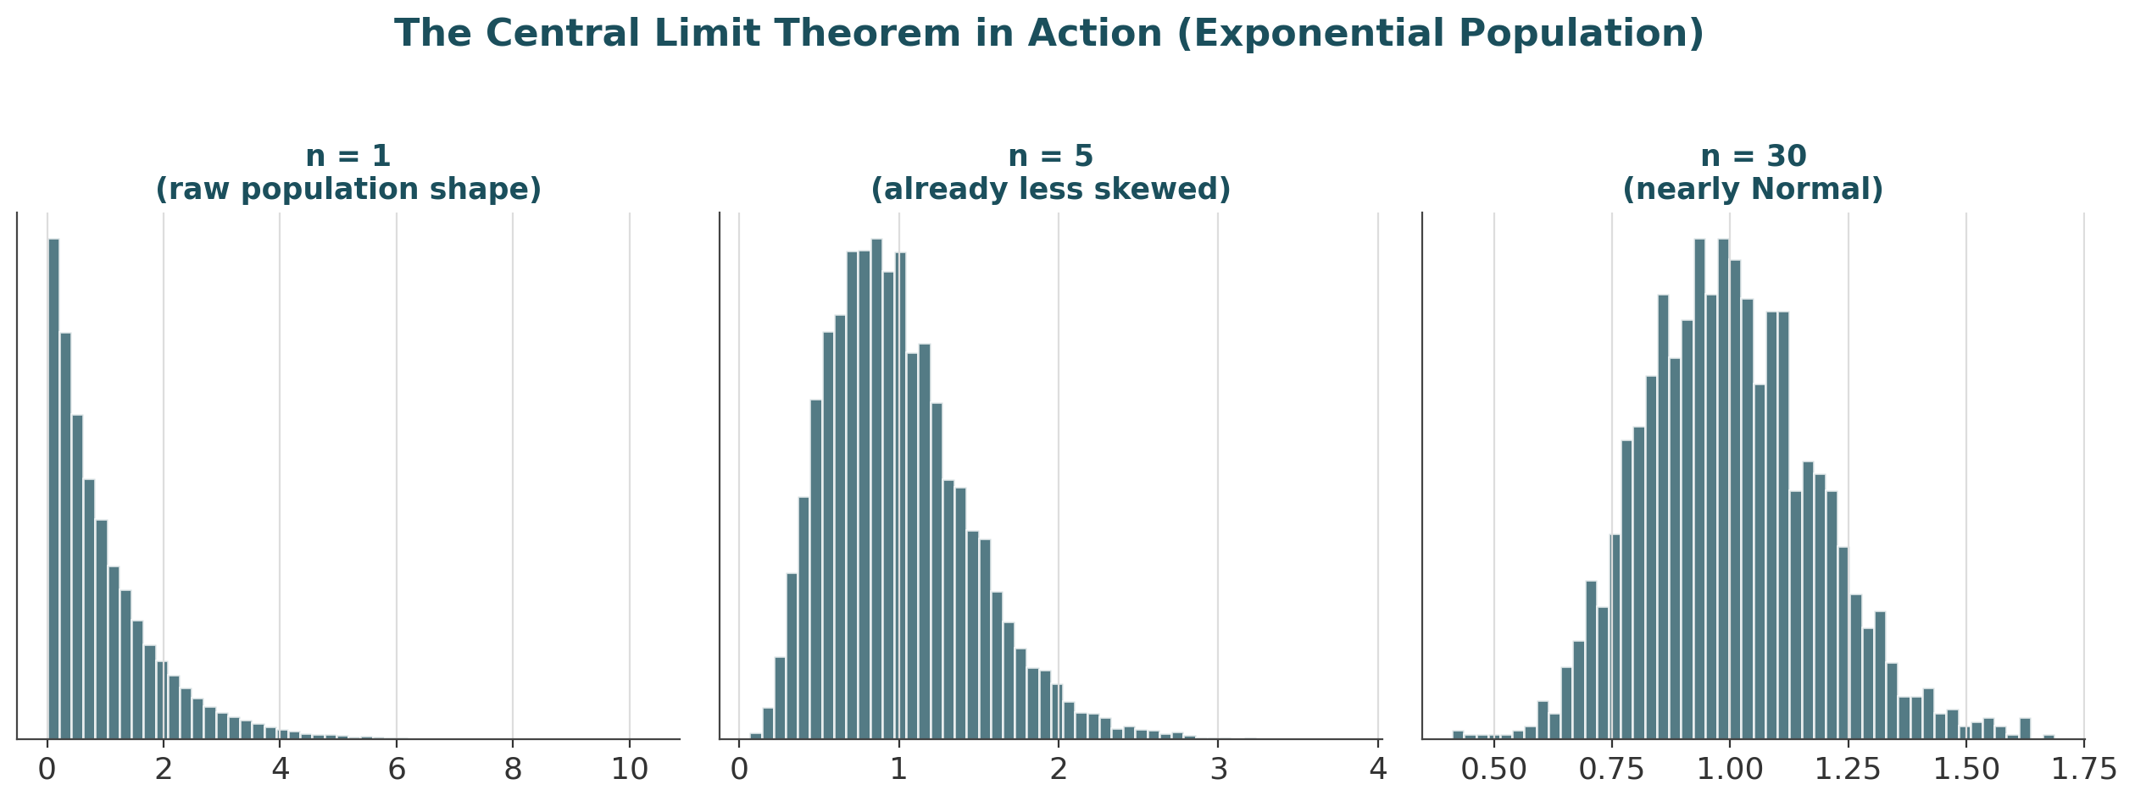
Figure 6.1 — However skewed the underlying population, the distribution of its sample mean approaches Normal shape as the sample size n grows — the essence of the Central Limit Theorem.
A working vocabulary of named distributions is essential because each one encodes a specific data-generating story. Among discrete distributions: a Bernoulli variable is a single yes/no trial; a Binomial variable counts successes across n independent Bernoulli trials; a Geometric variable counts trials until the first success; and a Poisson variable counts how many rare, independent events occur in a fixed window — the natural model for order arrivals or jump events. Among continuous distributions: a Uniform variable spreads probability evenly across a range; a Normal (Gaussian) variable is the symmetric bell curve produced by the CLT; a Lognormal variable is what you get when the logarithm of a variable is Normal — the standard model for asset prices, since prices cannot go negative but log returns can be Normal; an Exponential variable models waiting times between Poisson events; and the Student-t, Chi-square and F distributions arise directly out of statistical inference — t from estimating a mean with unknown variance, Chi-square from summing squared Normal variables (used in variance tests), and F from comparing two variances (used to compare model fits). Section 6.6 collects the defining formulas and financial use case for each.
When more than one random variable is in play, the joint distribution describes the full probability structure over all of them simultaneously; the marginal distribution of any single variable is recovered by summing (discrete case) or integrating (continuous case) the joint distribution over all the other variables; and the conditional distribution of one variable given another is the joint distribution restricted to, and renormalised over, a fixed value of the conditioning variable. In multi-asset finance, the joint distribution of returns across instruments is the object that ultimately matters for portfolio risk — the marginals alone (each asset's individual behaviour) say nothing about how badly things can go wrong together.
This is exactly where correlation's limits become dangerous, and where copulas and extreme value theory (covered in depth at Level 5, introduced here only as awareness) start to matter. A copula is a mathematical device that separates the marginal behaviour of each variable from the dependence structure linking them, which matters because two assets can have a modest linear correlation most of the time yet crash together almost every time markets fall sharply — a pattern called tail dependence that an ordinary correlation number cannot see. Extreme value theory studies the tail of a distribution directly rather than its average behaviour, asking questions like “how bad could the worst 1-in-1000-day loss plausibly be?” — a question the CLT and an assumed Normal distribution both answer badly, because both describe typical behaviour, not rare and extreme behaviour. Figure 6.2, in the worked examples below, shows exactly how much a Normal assumption can understate real tail risk.

6.3 Worked Example — Bayes' Theorem for Signal Reliability
- A regime-detection model flags “regime shift” on a given day. Historically, a true regime shift occurs on about 5% of days (the prior, P(shift) = 0.05).
- When a shift is genuinely happening, the model correctly flags it 95% of the time: P(flag | shift) = 0.95 (the true positive rate).
- When there is no shift, the model still flags one 10% of the time: P(flag | no shift) = 0.10 (the false positive rate).
- By the law of total probability, P(flag) = P(flag|shift)·P(shift) + P(flag|no shift)·P(no shift) = 0.95×0.05 + 0.10×0.95 = 0.1425.
- Applying Bayes' theorem: P(shift | flag) = 0.95×0.05 / 0.1425 ≈ 0.333, i.e. only a 33.3% chance the flag reflects a genuine regime shift — despite the model looking “95% accurate” on paper.
- This is the base-rate fallacy in action: because true shifts are rare to begin with, most flags are false alarms even from a seemingly reliable model. If a second, independent flag fires the next day, updating again with the new prior of 33.3% pushes the posterior to about 82.6% — confirmation from independent evidence moves belief far faster than a single flag ever could.
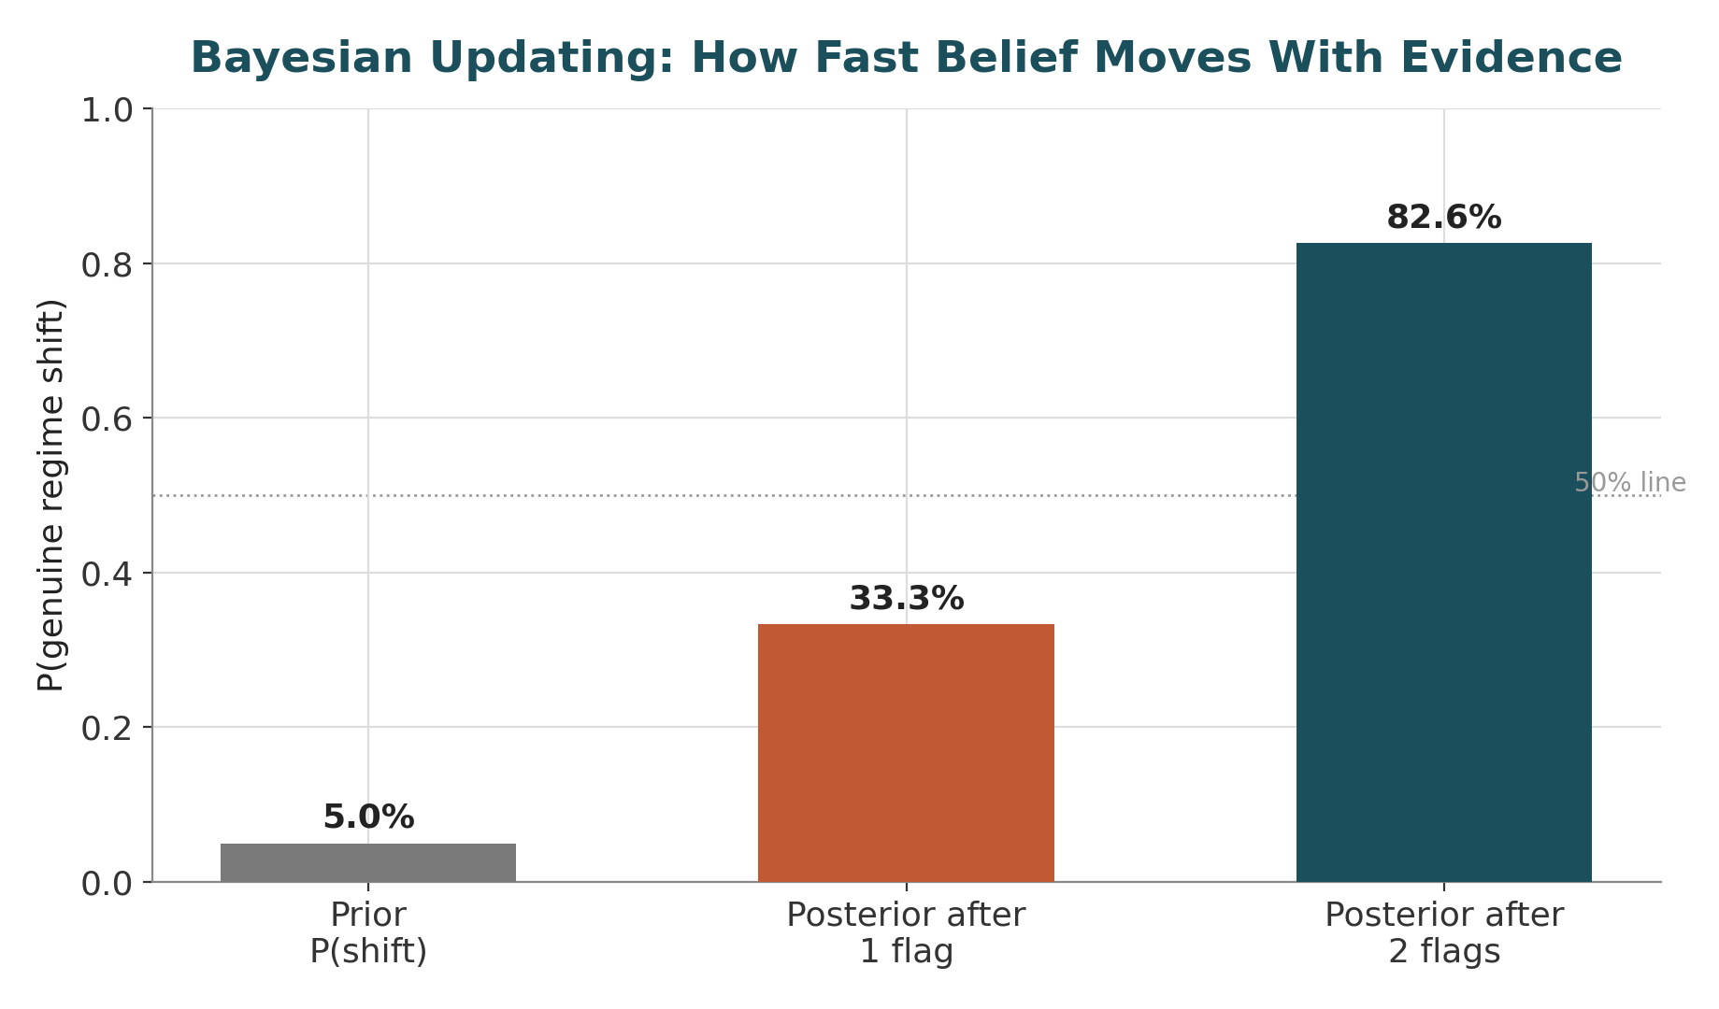
Figure 6.2 — A single positive flag only lifts the probability of a genuine regime shift from a 5% prior to 33.3%; a second, independent confirming flag lifts it to 82.6%. Low base rates make single alerts far less conclusive than their stated accuracy suggests.

6.4 Worked Example — Normal vs. Student-t and the Cost of Ignoring Heavy Tails
- A simulated daily return series (2,000 observations) is built with genuinely heavy tails, then two candidate distributions are fitted to it: a Normal, using the sample mean and standard deviation, and a Student-t, fitted by maximum likelihood.
- The fitted Normal has μ ≈ −0.0003 and σ ≈ 0.0095; the fitted Student-t has approximately 4.6 degrees of freedom — a low value, since a low degree-of-freedom count is exactly what produces fat tails, and the t-distribution converges to the Normal as degrees of freedom → ∞.
- Under the Normal fit, the theoretical probability of a move beyond 3 standard deviations is about 0.27%, implying such a move should occur roughly once every 370 trading days (about once every 1.5 years).
- The actual (empirical) frequency of moves beyond 3 standard deviations in the simulated series is about 1.25% — roughly once every 80 trading days, more than 4.5× more often than the Normal distribution predicts.
- This is the practical cost of a Normal assumption: it is not just “slightly off” in the tails, it is off by a multiple — and it is precisely the tails that determine drawdown risk, margin calls and VaR breaches. This is the calculation the Level 1 practical exercise (fitting Normal vs. Student-t to a real return series and comparing with a QQ-plot) is designed to make concrete.
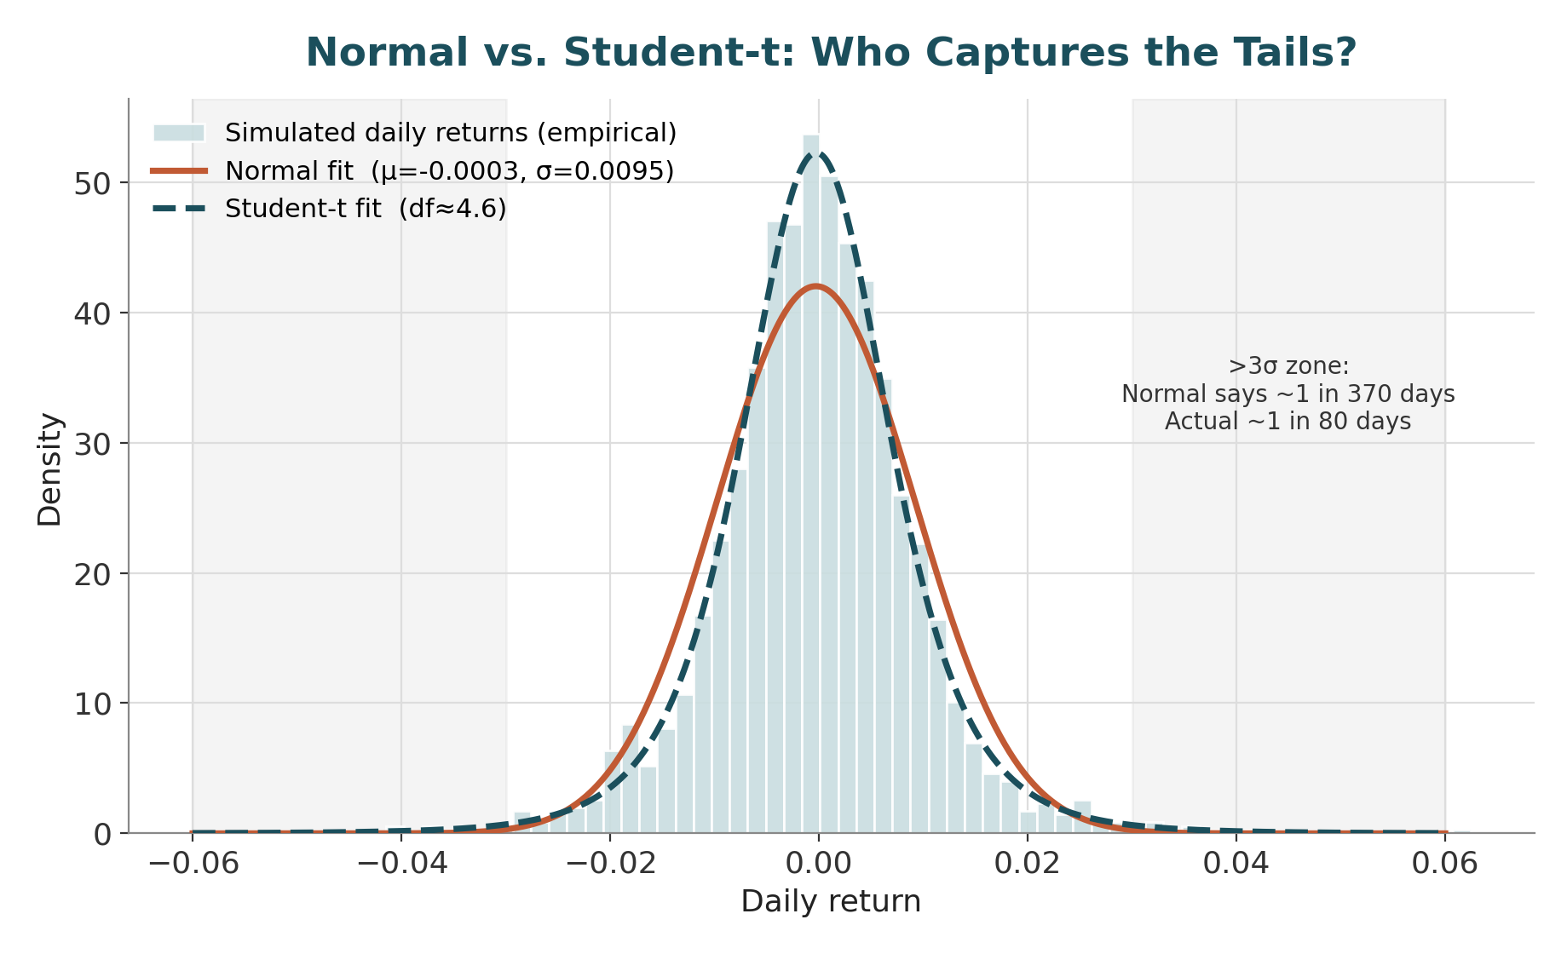
Figure 6.3 — The Student-t fit (dashed) tracks the empirical histogram's peak and shoulders far more closely than the Normal fit (solid); the Normal systematically underweights the probability of large moves in both tails.

6.5 Reference Table — Key Formulas
Quantity | Formula | Interpretation
Conditional probability | P(A|B) = P(A∩B) / P(B) | Probability of A, restricted to the world where B happened
Independence | P(A∩B) = P(A)·P(B) | Knowing B gives no information about A
Bayes' theorem | P(A|B) = P(B|A)·P(A) / P(B) | Updating a prior belief P(A) using new evidence B
Expectation | E[X] = Σ x·P(X=x) | Probability-weighted average outcome
Variance | Var(X) = E[(X−E[X])²] | Average squared spread around the mean
Covariance | Cov(X,Y) = E[(X−E[X])(Y−E[Y])] | Whether X and Y move together (sign) and how strongly (magnitude)
Correlation | ρ = Cov(X,Y) / (σₓσᵧ) | Unit-free linear co-movement, bounded in [−1, +1]
Law of total expectation | E[X] = E[E[X|Y]] | Overall mean = weighted average of group means
Law of total variance | Var(X) = E[Var(X|Y)] + Var(E[X|Y]) | Total variance = within-group + between-group variance
Law of Large Numbers | X̄ₙ → E[X] as n → ∞ | Sample average converges to the true mean
Central Limit Theorem | (X̄ₙ − μ) / (σ/√n) → N(0,1) | Sampling distribution of the mean approaches Normal as n grows

6.6 Reference Table — Common Distributions
Distribution | Type | Mean / Variance | Typical Financial Use
Bernoulli(p) | Discrete | p / p(1−p) | A single win/loss trade outcome
Binomial(n,p) | Discrete | np / np(1−p) | Number of winning trades out of n independent bets
Geometric(p) | Discrete | 1/p / (1−p)/p² | Number of trials until the first stop-loss or first win
Poisson(λ) | Discrete | λ / λ | Count of rare events in a window (order arrivals, jumps, defaults)
Uniform(a,b) | Continuous | (a+b)/2 / (b−a)²/12 | A baseline “no information” prior over a bounded range
Normal(μ,σ²) | Continuous | μ / σ² | Default (approximate) model for log returns; CLT limit
Lognormal(μ,σ²) | Continuous | e^(μ+σ²/2) / — | Asset prices, since ln(price) is modelled as Normal
Exponential(λ) | Continuous | 1/λ / 1/λ² | Waiting time between Poisson-arriving events
Student-t(ν) | Continuous | 0 / ν/(ν−2), ν>2 | Heavy-tailed returns; small-sample inference on the mean
Chi-square(k) | Continuous | k / 2k | Sum of k squared standard Normals; variance testing
F(d1,d2) | Continuous | Ratio-based | Ratio of two independent Chi-square variables; comparing variances/model fits

7. Statistics (Level 1, revisited at Levels 2–3, 6)
Covers: Descriptive statistics (mean/median/variance/std/quantiles/skew/kurtosis) · sampling · estimators (bias/consistency/efficiency) · confidence intervals · hypothesis testing · p-values · statistical power · Type I/II errors · MLE (awareness) · Bayesian estimation (awareness) · bootstrap/resampling · multiple testing · false discovery · statistical vs economic significance
▸ INTUITION FIRST
Statistics is what tells you whether the pattern you found is real, or just what randomness looks like in a small sample. A backtest reported without a confidence interval is a story, not evidence. Every time many variations of a strategy are tried and only the best one is reported, an impressive Sharpe ratio is being manufactured out of pure noise — statistics is the discipline built specifically to catch this before the market does.

7.1 Learning Position at a Glance
- What it is: The discipline of drawing defensible conclusions from data, and quantifying how confident those conclusions should be.
- Why it matters: This is the single most important subject in the entire curriculum for avoiding self-deception: it is what separates a real signal from noise that happened to backtest well.
- Prerequisites: Probability.
- Understand before proceeding: Do not interpret a Sharpe ratio, or claim a strategy ‘works’, before understanding sampling variability, confidence intervals and multiple-testing correction.
- Connects to Research: The entire validation stage of the research lifecycle (Part III) is applied statistics: hypothesis tests, out-of-sample checks, multiple-testing correction.
- Connects to Development: Statistical tests need to be implemented correctly and reproducibly in backtesting/validation code.
- Connects to Trading: Risk metrics reported to a desk (Sharpe, drawdown distributions) are sample statistics with real sampling error.
- Practical exercise: Backtest 50 random trading rules on the same data, record the best Sharpe ratio achieved, and use this to demonstrate multiple-testing bias empirically.
- Common beginner mistakes:
- Reporting a Sharpe ratio without a confidence interval or sample size context.
- Running many variations of a strategy and only reporting the best one (data snooping).
- Advanced extensions: Bayesian statistics, hierarchical models and causal inference (Level 6).
- Professional applications: Strategy validation; A/B testing execution algorithms; model risk assessment.

7.2 Concept Walkthrough
Descriptive statistics summarise a sample of data with a handful of numbers. The mean is the arithmetic average; the median is the middle value once sorted, and is far more robust to outliers — a single huge loss day distorts a mean much more than a median. Variance and standard deviation measure spread exactly as in probability, but computed from a sample rather than a theoretical distribution. Quantiles generalise the median to any percentile (the 5th percentile of a return series is a common, simple stand-in for a VaR-style tail measure). Skewness measures asymmetry — a strategy with occasional large losses and frequent small gains has negative skew, a pattern typical of option-selling and carry strategies. Kurtosis measures tail weight relative to a Normal distribution; the “excess kurtosis” of most financial return series is positive, another way of stating the heavy-tails point from Section 6.
Statistics distinguishes carefully between a population (the true, usually unobservable, data-generating process) and a sample (the finite, noisy draw actually observed). An estimator is a formula for turning a sample into a guess about a population quantity, and three properties determine whether that guess can be trusted. Bias is the average gap between the estimator and the true value across repeated samples — the sample mean is unbiased for the population mean, but the naive sample variance (dividing by n rather than n−1) is slightly biased downward, which is exactly why Bessel's correction exists. Consistency means the estimator converges to the true value as the sample grows (a direct application of the Law of Large Number from Section 6). Efficiency compares estimators by their variance: among unbiased estimators, the one with the smallest variance for a given sample size is preferred, since it wastes less information.
A confidence interval quantifies how much an estimate could plausibly move if the sampling were repeated. For a sample mean, the standard error SE = σ/√n measures the typical sampling variability of that mean, and a 95% confidence interval is (approximately, via the CLT) the point estimate ± 1.96×SE. The interpretation that trips up almost everyone: a 95% CI does not mean “there is a 95% probability the true value lies in this specific interval.” The true value is fixed, not random — what is random is the interval itself. The correct interpretation is that if this sampling and interval-construction procedure were repeated many times, about 95% of the resulting intervals would contain the true value. Section 7.4 below builds a full worked example around exactly this construction.
Hypothesis testing formalises the question “is this result likely to be a fluke?” A null hypothesis H₀ states the boring, no-effect scenario (e.g. “this strategy's true mean return is zero”); a test statistic measures how far the observed data sits from what H₀ predicts, in standard-error units; and the p-value is the probability of seeing a result at least as extreme as the one observed, if H₀ were actually true. A small p-value is evidence against H₀, not proof it is false, and it says nothing about the size or practical importance of the effect. Two error types bound the risk of getting this wrong: a Type I error is rejecting a true H₀ (a false positive — concluding a worthless strategy works), controlled by the significance level α (conventionally 5%); a Type II error is failing to reject a false H₀ (a false negative — missing a genuine edge), and statistical power is 1 minus the Type II error rate, i.e. the probability of correctly detecting a real effect of a given size. Power rises with sample size, with effect size, and as α is relaxed — which is exactly why short backtests on subtle strategies are so often underpowered to detect a genuine, but modest, edge.
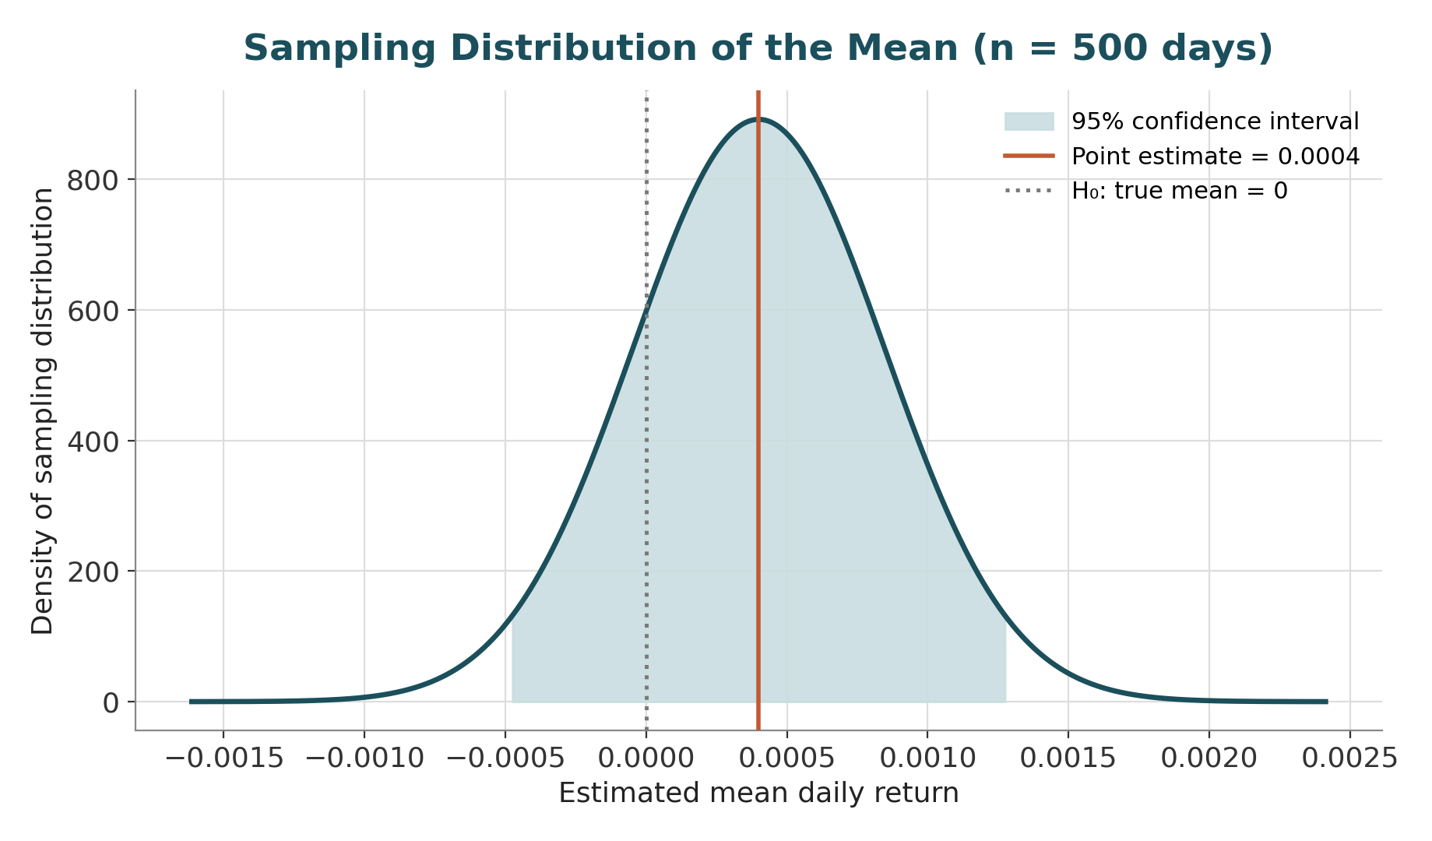
Figure 7.1 — The sampling distribution of an estimated mean daily return, with its 95% confidence interval shaded. Because the interval comfortably contains zero (the null hypothesis), the point estimate is not statistically distinguishable from ‘no edge.’
Two estimation frameworks are worth knowing about at an awareness level before they are studied properly at later levels. Maximum likelihood estimation (MLE) chooses the parameter values that make the observed data most probable under an assumed distributional family — it is the general-purpose machine behind most distribution-fitting, including the Student-t fit used in Section 6.4. Bayesian estimation instead treats the parameter itself as uncertain, combining a prior belief about it with the observed data (via Bayes' theorem) to produce a full posterior distribution over the parameter, rather than a single best-guess number. Both are covered in full only from Level 6 onward; the awareness to carry forward is simply that MLE answers “what parameter makes this data most likely?” while Bayesian estimation answers “given this data and what I believed beforehand, what should I believe now?”
When a statistic's sampling behaviour has no clean analytic formula — which is common for things like the Sharpe ratio, the maximum drawdown, or any quantile-based risk measure on a skewed sample — the bootstrap provides a general-purpose substitute. It works by resampling the observed data with replacement many thousands of times, recomputing the statistic of interest on each resample, and using the resulting spread of values as a stand-in for the true sampling distribution. This lets a confidence interval or standard error be built empirically for almost any statistic, without ever deriving its theoretical formula.
Multiple testing is the single most consequential concept for a quant researcher to internalise, because it is the mathematical explanation for why backtesting is so easy to fool yourself with. If a single test is run at a 5% significance level, there is a 5% chance of a false positive. But if 20 independent, genuinely worthless strategies are each tested at the 5% level, the probability that at least one appears “significant” purely by chance rises to roughly 1 − 0.95²⁰ ≈ 64%. This is exactly the mechanism explored numerically in Section 7.3. Two standard corrections exist: the Bonferroni correction divides the significance threshold by the number of tests performed (simple but conservative), while false discovery rate (FDR) control — typically via the Benjamini–Hochberg procedure — instead bounds the expected proportion of false positives among all rejected hypotheses, giving more statistical power when many tests are run simultaneously, as is typical in large-scale factor or signal screens.
Finally, statistical significance and economic significance are entirely different questions, and conflating them is a persistent source of bad decisions. A tiny, genuinely real effect can be statistically significant with enough data (a large enough sample makes almost any nonzero effect detectable) while being far too small to cover trading costs, financing, or operational overhead — statistically real but economically worthless. Conversely, a strategy can show an economically enormous in-sample return that is not statistically distinguishable from noise, simply because the sample is short — economically exciting but statistically unproven. Both the confidence interval and the p-value should always be reported alongside any headline number precisely to keep these two questions separate.

7.3 Worked Example — Multiple-Testing Bias from 50 Random Trading Rules
- 50 trading rules are simulated, each generating 500 days (≈ 2 years) of purely random daily returns with a true mean of exactly zero — by construction, none of these rules has any real edge.
- For each rule, the annualised Sharpe ratio is computed as (mean daily return / daily standard deviation) × √252. Across the 50 simulated rules, the resulting Sharpe ratios average ≈0.13 with a standard deviation of ≈0.89 — centred close to zero, exactly as expected for pure noise.
- The best of the 50 rules achieves an annualised Sharpe ratio of 2.38, and the worst achieves −2.51 — despite every single rule having zero true edge by construction.
- A Sharpe ratio of 2.38 would, on its own and without this context, look like an outstanding, fundable strategy. It is, in this case, pure sampling noise that surfaced by chance because 50 independent draws were examined and only the best one was kept.
- This is the mechanism behind data snooping: the more strategy variations tested, the more likely one of them looks spectacular purely by luck. The correct response is either a multiple-testing correction (raising the bar for significance in proportion to the number of variants tried) or genuine out-of-sample validation on data the strategy-selection process never saw.
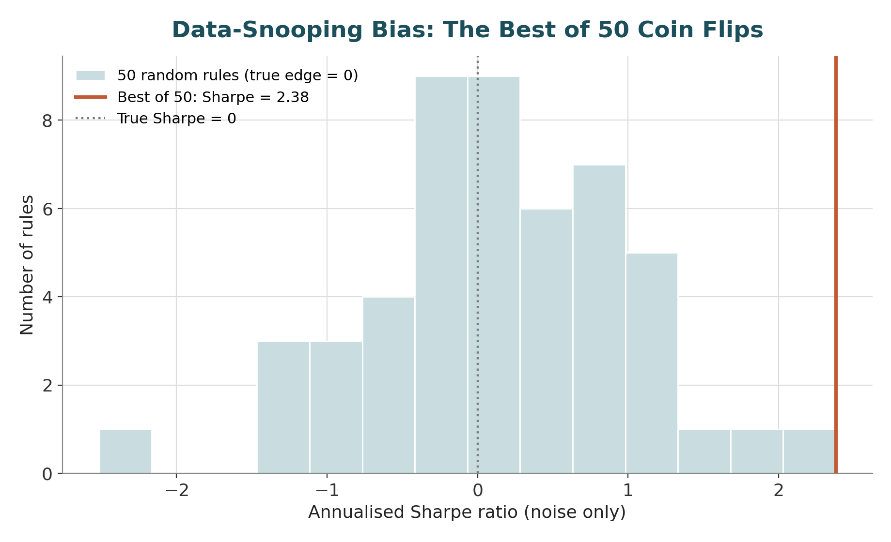
Figure 7.2 — The distribution of annualised Sharpe ratios across 50 rules that all have zero true edge. The best-performing rule reaches a Sharpe of 2.38 by chance alone — a reminder that the maximum of many noisy draws is not a reliable estimate of any one draw's true quality.

7.4 Worked Example — Confidence Interval and Hypothesis Test on a Strategy's Sharpe Ratio
- A strategy shows a mean daily return of 0.04% (0.0004) and a daily standard deviation of 1.0% (0.01), observed over n = 500 trading days — roughly two years of daily data.
- The daily Sharpe ratio is 0.0004 / 0.01 = 0.04, which annualises to 0.04 × √252 ≈ 0.63 — a respectable-looking headline number for a two-year track record.
- The standard error of the mean is SE = 0.01/√500 ≈ 0.000447. Testing H₀: true mean daily return = 0 gives a t-statistic of 0.0004 / 0.000447 ≈ 0.89, with a two-sided p-value of ≈ 0.37 — nowhere near the conventional 5% significance threshold.
- The 95% confidence interval for the true mean daily return is approximately [−0.00048, +0.00128], which comfortably contains zero. Applying the same logic to the annualised Sharpe ratio (using an approximate standard-error formula for the Sharpe estimator) gives a 95% CI of roughly [−0.76, +2.03] — an interval so wide that it cannot rule out the strategy having no edge at all, or even a mildly negative one.
- The takeaway mirrors Section 7.3 exactly: an eye-catching Sharpe ratio of 0.63 over two years of daily data is not, by itself, statistically distinguishable from zero. This is precisely the reasoning the “Understand before proceeding” note in Section 7.1 is guarding against — a Sharpe ratio without its confidence interval and sample-size context can look far more convincing than the underlying evidence actually supports.

7.5 Reference Table — Key Formulas
Quantity | Formula | Interpretation
Sample mean / variance | X̄ = (1/n)ΣXᵢ , s² = (1/(n−1))Σ(Xᵢ−X̄)² | Unbiased point estimates of the population mean and variance
Standard error of the mean | SE = s / √n | Typical sampling variability of the sample mean
Confidence interval (mean) | X̄ ± z(or t)·SE | Range plausibly containing the true mean under repeated sampling
t-statistic | t = (X̄ − μ₀) / SE | Standardised distance of the estimate from the null value
p-value | P(|T| ≥ |t observed| ∣ H₀ true) | Probability of a result this extreme if H₀ were true
Statistical power | 1 − P(Type II error) | Probability of correctly detecting a true effect of a given size
Sharpe ratio (annualised) | SR = (μ/σ)×√252 | Risk-adjusted return; requires a confidence interval to interpret safely
Standard error of Sharpe | SE(SR) ≈ √((1+½SR²)/n) | Sampling uncertainty of an estimated Sharpe ratio (Lo, 2002)
Bonferroni threshold | α_adjusted = α / m | Stricter significance bar when m hypotheses are tested simultaneously
Benjamini–Hochberg (FDR) | Reject Hᵢ where p₍ᵢ₎ ≤ (i/m)·q | Controls expected false-discovery proportion across m tests

